

END Term assessment

Great Learning/Deakin University



December 24, 2023

Yatharth deoly

224207854

Contents

**Question-1:** 2

**Question-2:** 4

**Question-3:** 5

**References:** 7

# **Question-1:**

*a) Explain why a Linear Programming (LP) model would be suitable for this case study?*

Linear programming (LP) is suitable for this case study because it involves the decision-making process of optimizing a linear objective function, subject to linear equations and inequalities.

In this case, the objective of this study is to find the combination of shirts and pants which maximizes the profit.

The constraints used here are linear in nature, i.e. daily demand for number of shirts, labour hours for each department (cutting, sewing and packaging), unlimited demand for pants and non-negative constraints.

*b) Formulate a LP model to help the factory management to determine the optimal daily production schedule that maximizes the profit while satisfying all constraints.*

Let’s consider decision variables as:

x = number of shirts produced

y = number of pants produced

Objective function (Profit function to maximize):

Maximize Z = 10x + 8y

Constraints:

1. Cutting department:
   1. Calculating total minutes (20workers * 8hours * 60mins) -> 9600
   2. 40x + 20y <= 9600
2. Sewing department:
   1. Calculating total minutes (50workers * 8hours * 60mins) -> 24000
   2. 40x + 100y <= 24000
3. Packaging department:
   1. Calculating total minutes (14workers * 8hours * 60mins) -> 6720
   2. 20x + 20y <= 6720
4. Shirts demand: x <= 180
5. Non negative: x >= 0, y >= 0

*c) Use the graphical method to find the optimal solution. Show the feasible region and the optimal solution on the graph. Annotate all lines on your graph. What is the optimal daily profit for the factory?*

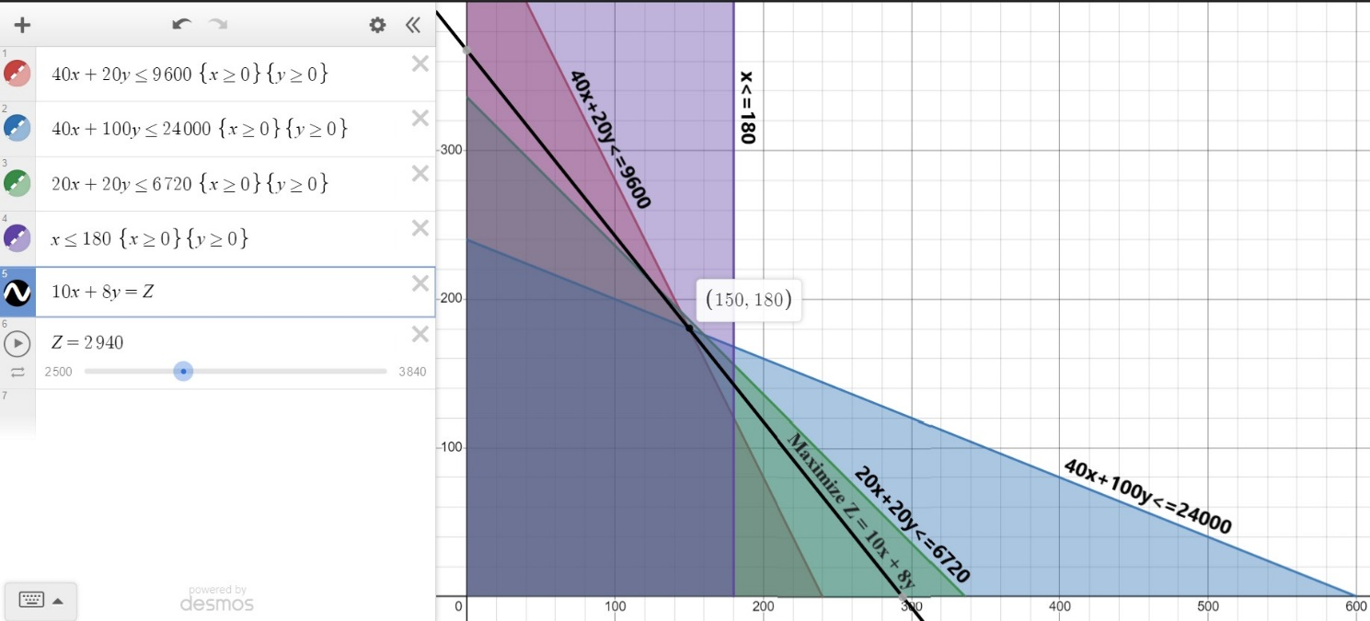

The optimal solution calculated using graphical method is:

* Maximum daily profit: $2940
* Optimal number of shirts produced: 150
* Optimal number of pants produced: 180

*d) Find the range for the profit ($) per shirt (if any) that can be obtained without affecting the optimal point of part.*

As to find range for the profit per shirt without affecting the optimal point (150,180), we can perform sensitivity analysis on our objective function, by changing coefficient of shirts(x), denoting coefficient as ‘s’

Maximize Z = c*x + 8y

Changing profit per shirt, i.e. ‘c’ on optimal point:

* Allowable increase in profit per shirt
  + So, if we increase ‘c’ with 6 points, it will have upper bound point.
  + So upper bound of ‘c’ can be 16.
  + Profit when z=16x+8y, 3840.

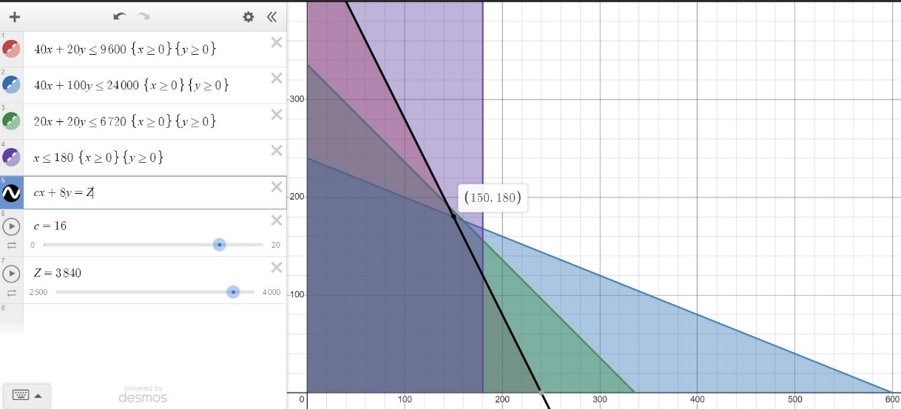

* Allowable decrease in profit per shirt
  + So, if we decrease ‘c’ with 6.8 points, it will have lower bound point.
  + So lower bound of ‘c’ can be 3.2.
  + Profit when z=3.2x+8y, 1920.

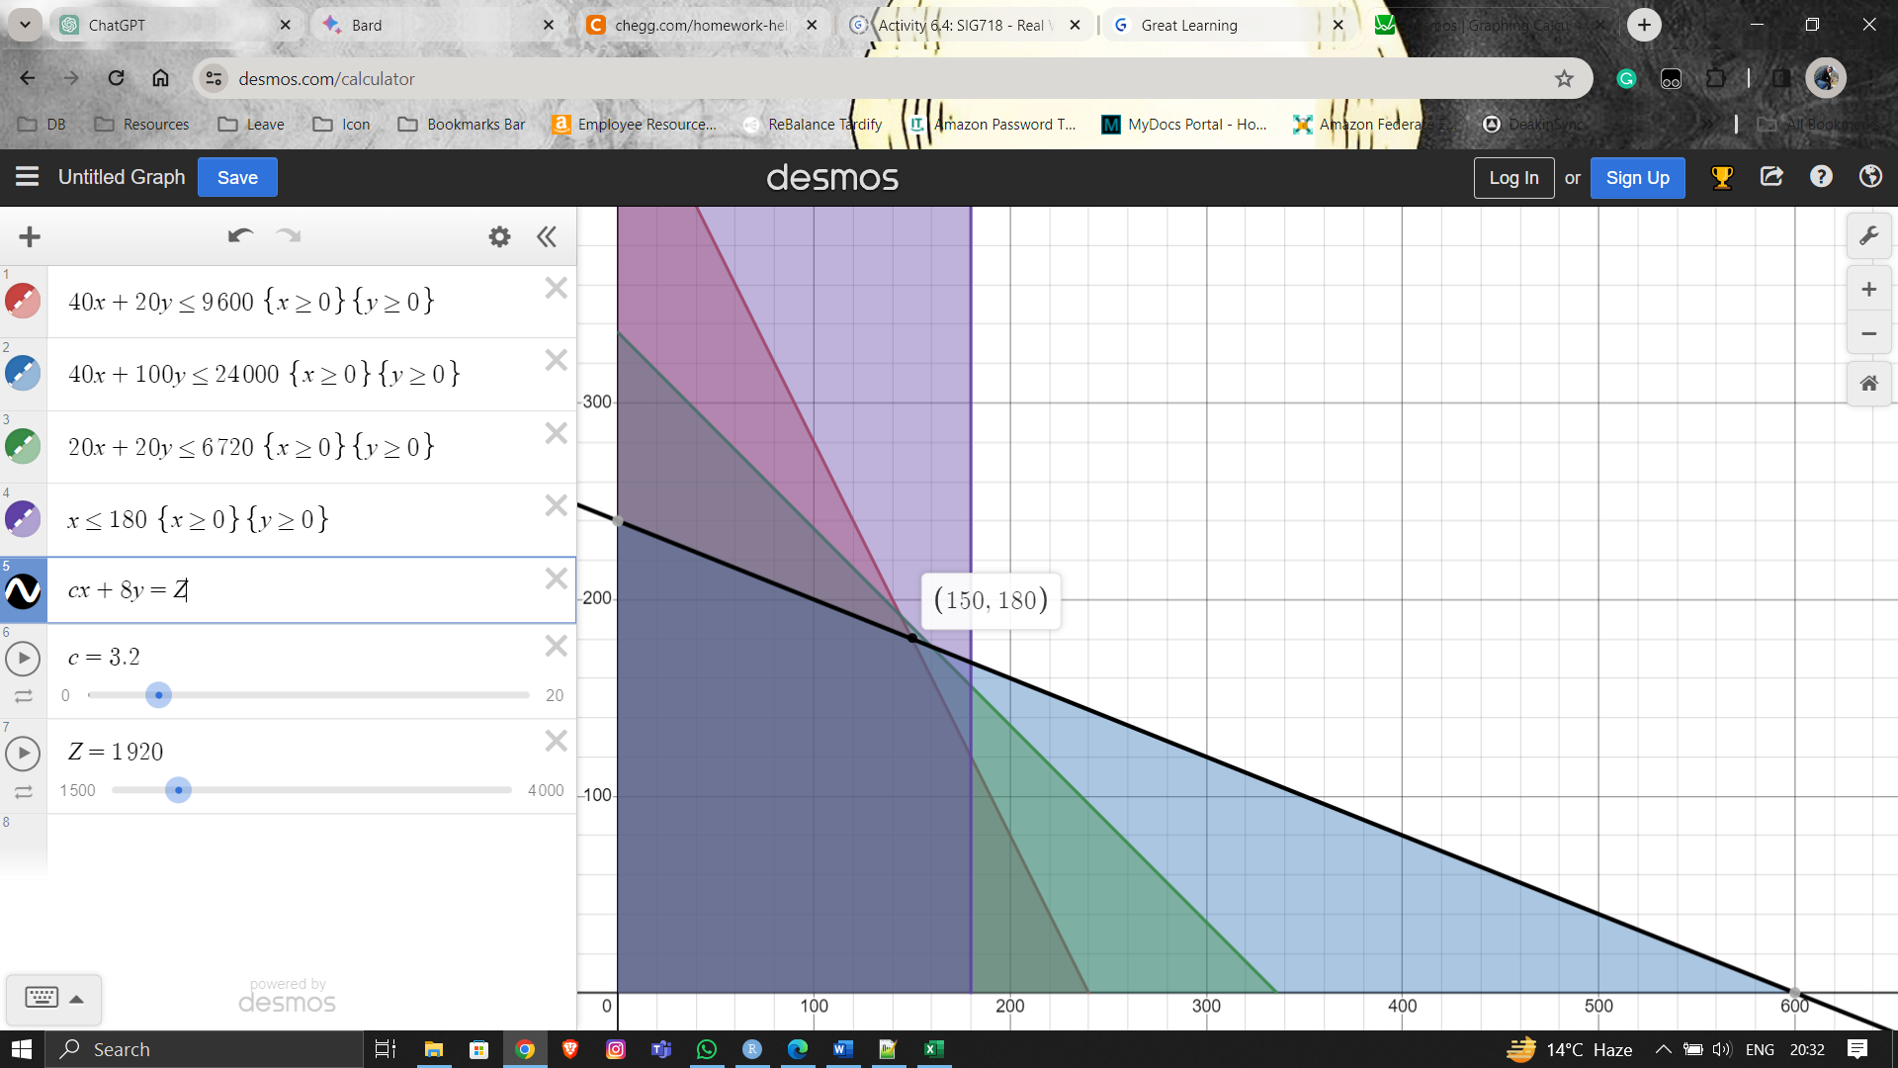

* Range of `c` without affecting optimal point ranges from 3.2 to 16 or we can say as Objective Coefficient as 10 with allowable increase as 6 and allowable decrease as 6.8.

# **Question-2:**

Let xij be a decision variable that denotes the number of tons of products j for j ∈ {1 = Bloom, 2 = Amber, 3 = Leaf} to be produced from Materials i ∈ {C=Cotton, W=Wool, N=Nylon}.

Demand constraints:

* x11 + x21 + x31 <= 4200
* x12 + x22 + x32 <= 3200
* x13 + x23 + x33 <= 3500

Minimum cotton proportion constraints:

* 0.5x11 – 0.5x21 – 0.5x31 >= 0
* 0.4x12 – 0.6x22 – 0.6x32 >= 0
* 0.5x13 – 0.5x23 – 0.5x33 >= 0

Minimum wool proportion constraints:

* -0.4x11 + 0.6x21 – 0.4x31 >= 0
* -0.4x12 + 0.6x22 – 0.4x32 >= 0
* -0.3x13 + 0.7x23 – 0.3x33 >= 0

Objective function (Maximize):

* Sales - Cost - Price
* 15x11 + 10x21 + 25x31 + 11x12 + 6x22 + 21x32 + 15x13 + 10x23 + 25x33



LP model:

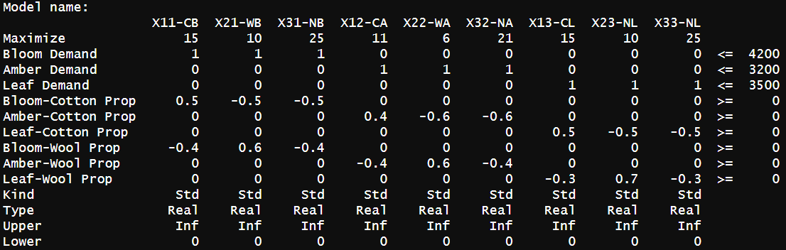

Objective function value: 141850

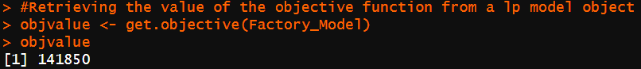

Decision variables values:

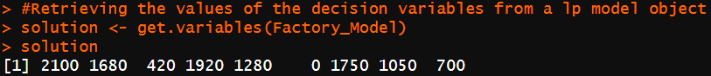



# **Question-3:**

*(a) State reasons why/how this game can be described as a two-players-zero-sum game*

* There are two construction companies involved in the bidding process, i.e. Giant and Sky, for the right to build in a field. So, it is a two-player game.
* Since the total gain for one player equals the total loss for the other, henceforth the game is zero-sum. In this case, the bid amount is the payoff and only one company will get the field. So, if Giant wins the bid, then Sky losses the field and its bidding cost and vice-versa.
* Total gain and total loss add up to zero:
  + Tie (both are equal) -> Giant wins, i.e. Giant (+1), Sky (-1) = 0
  + Giant wins: Giant (+1), Sky (-1) = 0
  + Sky wins: Sky (+1), Giant (-1) = 0

*(b) Considering all possible combinations of bids, formulate the payoff matrix for the game.*

A payoff matrix is a table that shows the options available to players and the possible outcomes of strategic decision-making. The rows of table represent possibles bids by SKY and columns represent possible bids by GIANT. The values in the matrix indicate the payoff for Sky given the combination of bids. Negative values represent losses for Sky, and the matrix structure captures the zero-sum nature of the game.

The payoff matrix for Sky, representing the gains/losses for each bidding strategy against Giant.

Rows represent SKY strategies and columns represents GIANT strategies.

**Payoff Matrix:**



$$\begin{matrix}-1 & -1 & -1 & -1 & 1 \\ 1 & -1 & -1 & -1 & 1 \\ 1 & 1 & -1 & -1 & 1 \\ 1 & 1 & 1 & -1 & 1 \\ 1 & 1 & 1 & 1 & -1\end{matrix}$$

*(c) Explain what is a saddle point. Verify: does the game have a saddle point?*

A saddle point is the position where the maximum of the row minima coincides with the minimum of the column maxima.

Steps to find saddle point:

* For row:
  + Find the minimum payoff for each row.
  + After that choose the row with the maximum from minimum payoffs calculated in above point.
* For column:
  + Find the maximum payoff for each column.
  + After that choose the column with the minimum from maximum payoffs calculated in above point.
* If row maxMin and column minMax value are same then we have found the saddle point where these points are coinciding.



In this case there is no saddle point or we can say pure strategy doesn’t exist, Lower value of the game(L) and Upper value of the game(U) are different.

As L = -1 and U = 1, the value of the game: v is somewhere between: [-1,1] (i.e. between -1 and 1 inclusive).

**Using Linear Programming for SKY**

Suppose SKY chooses the mixed strategy (c1, c2, c3, c4, c5).

* If Giant chooses strategy 1, the expected payoff is (–c1 + c2 + c3 + c4 + c5) as a
* If Giant chooses strategy 2, the expected payoff is (–c1 – c2 + c3 + c4 + c5) as b
* If Giant chooses strategy 3, the expected payoff is (–c1 – c2 – c3 + c4 + c5) as c
* If Giant chooses strategy 4, the expected payoff is (–c1 – c2 – c3 – c4 + c5) as d
* If Giant chooses strategy 5, the expected payoff is (c1 + c2 + c3 + c4 – c5) as e

The following LP optimization to find the minimum of five numbers: a, b, c, d, e.

Objective function: Max v

where:

* v <= a => v – a <= 0 => v + c1 – c2 – c3 – c4 – c5 <= 0
* v <= b => v – b <= 0 => v + c1 + c2 – c3 – c4 – c5 <= 0
* v <= c => v – c <= 0 => v + c1 + c2 + c3 – c4 – c5 <= 0
* v <= d => v – d <= 0 => v + c1 + c2 + c3 + c4 – c5 <= 0
* v <= e => v – e <= 0 => v – c1 – c2 – c3 – c4 + c5 <= 0
* c1 + c2 + c3 + c4 + c5 = 1
* ci >= 0, where i = 1, 2, 3, 4, 5

LP Model:

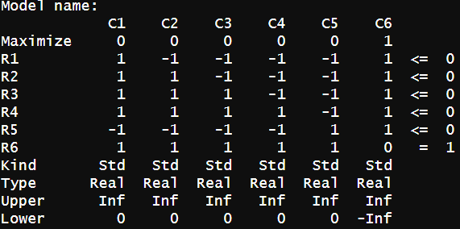

Objective function value as 0, as this value needs to be in range of L (-1) and U (1).

The value of a game in game theory can be zero. A game with a value of zero is considered fair, meaning that the wins and losses for each player balance out on average.

Decision variables values: Probability of choosing Strategy-1 is 50% and Strategy-5 is 50%.

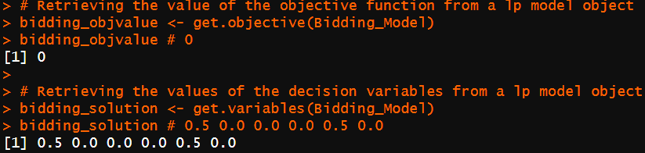

# **References:**

* Deakin library
* Olympus dashboard
* https://cran.r-project.org/